October 7, 2003

To: The Old North Davis Neighborhood Association Board Members
Davis, CA 95616

RE: 530 F Street – PA #16-03, and DR #07-03

Dear Members of the Board:
The City is receipt of an application to add a second dwelling to the property located at 530 F Street. The two-story second dwelling unit is proposed to be 1,176 square feet and located upon the southwest side of the property. Because the proposed project is located within an R-2 (Residential One and Two-Family) Conservation District the project applicant is required by the City to take the proposal through the City’s design review process. This type of permit is an administrative permit.

As a courtesy to the Association, the City is informing you that we are in receipt of the application and have provided a vicinity map, site plan, elevations, floor plans, and some streetscape photos and simulations so that you may view the proposed project. The City invites your comments so that we may include them in the evaluation of the application. Enclosed you will find a project comment sheet. Please note the project as proposed is consistent the City’s zoning standards and the design guidelines for the Old North Neighborhood District.

Please provide your comments by no later than October 13, 2003 either orally to the following number (530) 757-5610, extension no. 7244 or in writing at rrowland@ci.davis.ca.us or at the following mailing address:

Attention: Rhys Rowland, Assistant Planner
Planning and Building Department
City of Davis, City Hall
23 Russell Boulevard.
Davis, CA 95616

Thank you very much for your attention in this matter and please feel free to contact me should you have any questions regarding this letter or the project.

Sincerely,

Rhys Rowland
Assistant Planner

Cc: Lynne Journey
Kevin Fong

Enclosures: Attachment 1 – Vicinity Map
Attachment 2 - Site Plan
Attachment 3 – Elevations and Site Plan
Attachment 4 - Elevations
Attachment 5 – Elevations and Cross Section
Attachment 6 - Floor Plans
Attachment 7 - Photos
Attachment 8 – Streetscape Simulation
Attachment 9 – Comment Sheet

O:Common/Rhys Rowland/Planning Applications/Design Review/530 F Street/ Letter to the Old North Davis Neighborhood Assoc.doc

Attachment 1
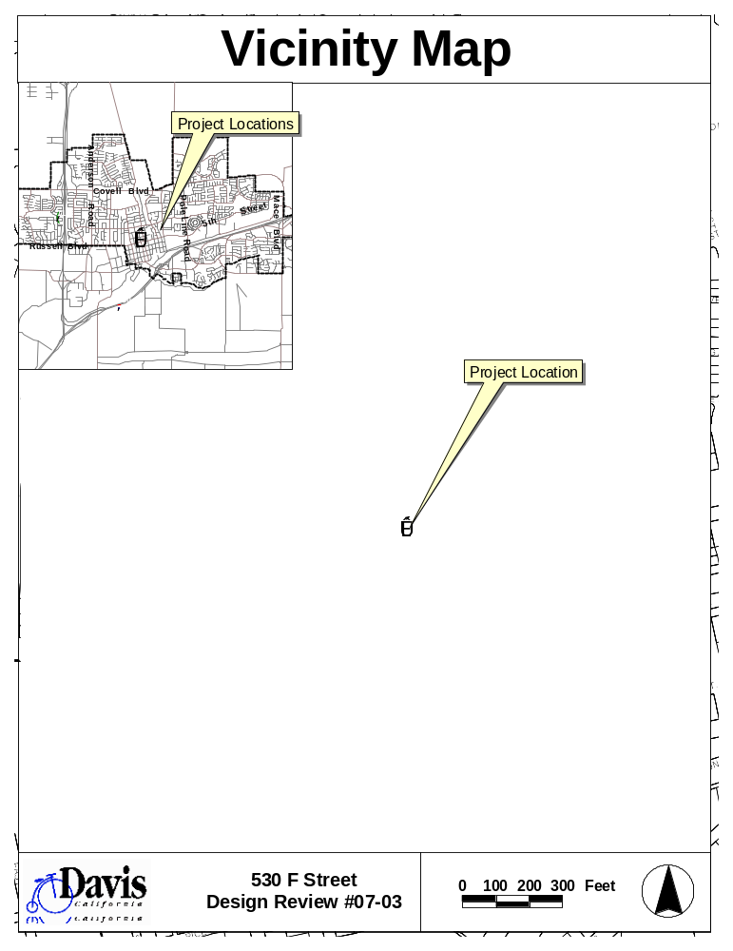
Attachment 2 - Site Plan
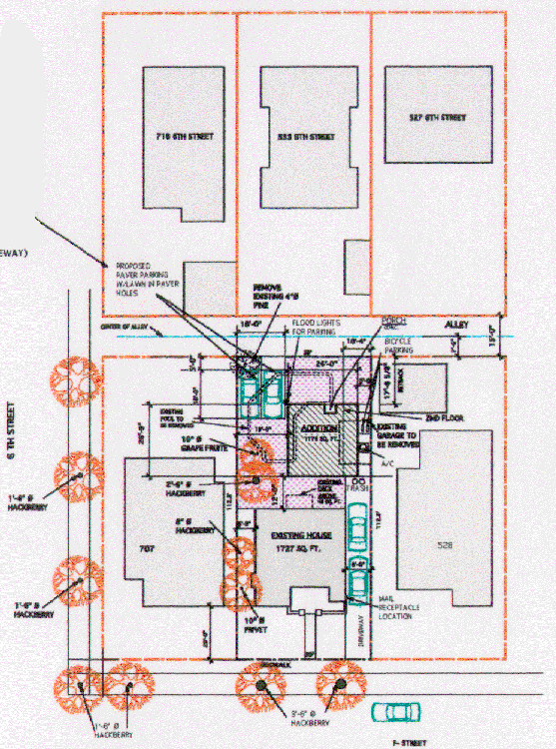
Attachment 3 – Elevations and Site Plan
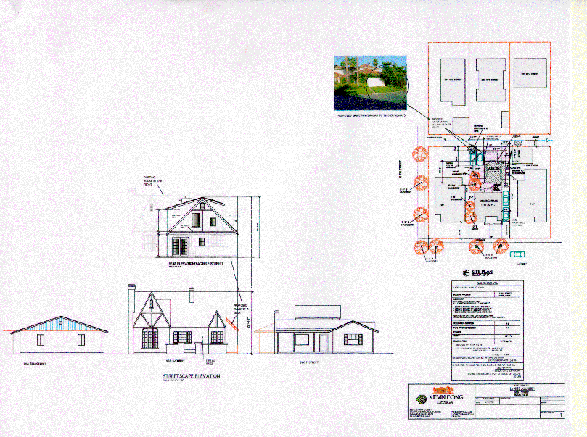

Attachment 4 - Elevations
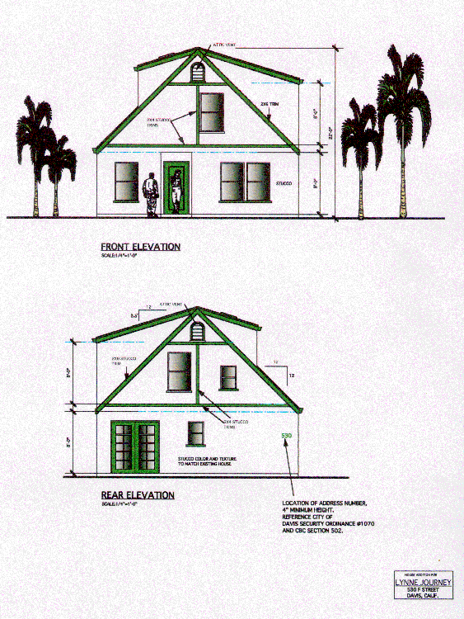
Attachment 4 – Elevations Cont.
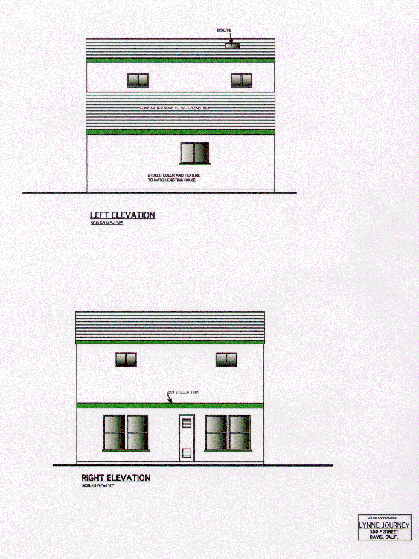
Attachment 5 - Elevations and Cross Section
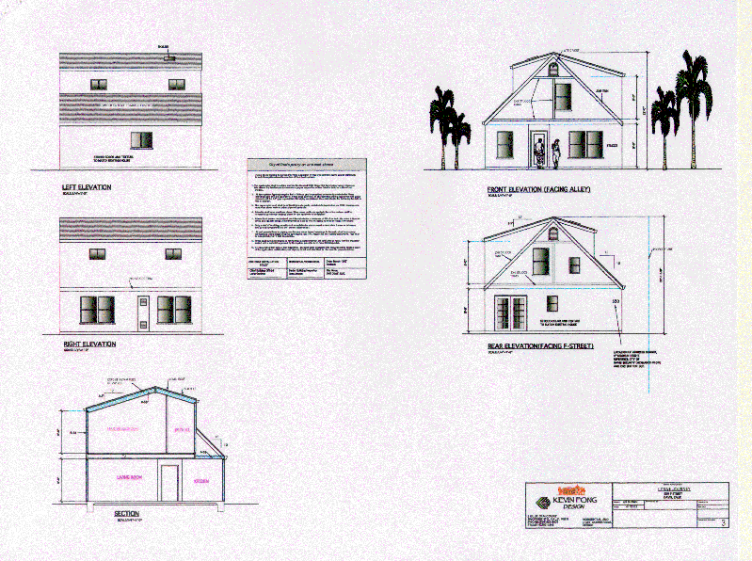
Attachment 6 – Floor Plans
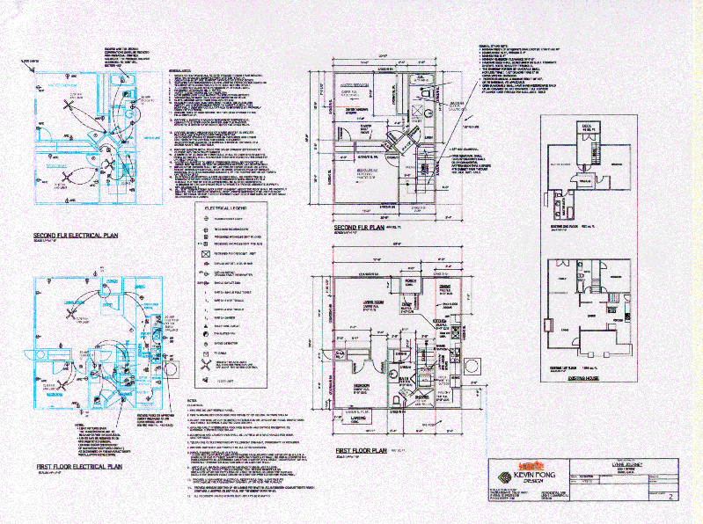
Attachment 7 - Photos
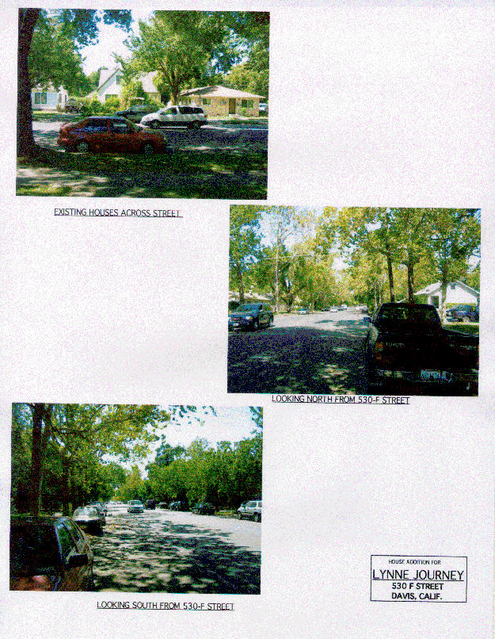
Attachment 8 - Streetscape Simulation
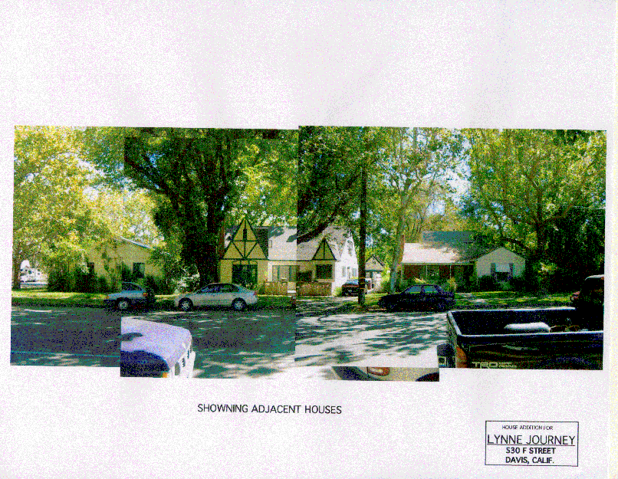
Comments Form
Public Outreach for 530 F Street
Please Provide Comments no later than October 13, 2003 5:00 PM

Please provide specific comments or concerns about the proposed project):

Questions that you feel should be addressed by the applicant or staff:

Planning Process (Questions, clarifications, concerns or issues):

Any other comments, issues, or concerns?:

Please submit this form or any Rhys Rowland
written or oral comments to: City of Davis
Planning and Building Department
23 Russell Boulevard
Davis, CA 95616
E-Mail: rrowland@ci.davis.ca.us

Phone: (530)757-5610 ext. #7244

